|  |
| --- |
| Bronze Yasuo Mains |
| 2D Side Scrolling Game C++ |
| “Just Keep Mvoing”  Version #01  All work Copyright © 2020 by Bronze Yasuo Mains.  All rights reserved.  **Geerthan Kanthasamy**  April 5th 2020 |
|  |

**Table of Contents**

* Game Description
* Game Play Mechanics
* Controls
* Interface Sketch
* Menu and Screen Descriptions
* Scoring
* Art/Multimedia Index

**Version History**

Version#01

<https://github.com/Exzeed/2D-Scrolling-Game>

**I. Game Description**

The slot machine starts once the “Spin” button is pressed; from there it generates a result that the graphic reflects. The player’s earnings are based on the end result and the amount betted and can continue, quit or reset using the respective buttons.

**II. Game Play Mechanics**

Players bet their money for each spin, the amount they get back is dependent their bet and the slot’s result. Player cannot bet an amount higher than what they have (and so can’t bet if amount is 0).

**III. Controls**

Everything is handled through mouse control (left-click).

**IV. Interface Sketch**

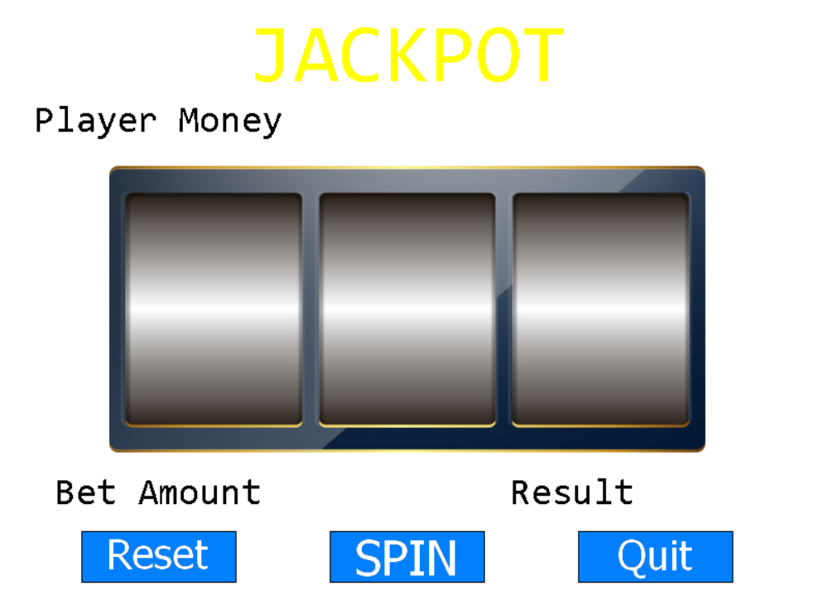

**V. Menu and Screen Descriptions**

Start Screen: 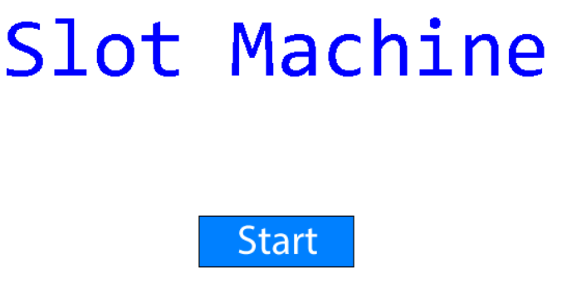

End Screen:

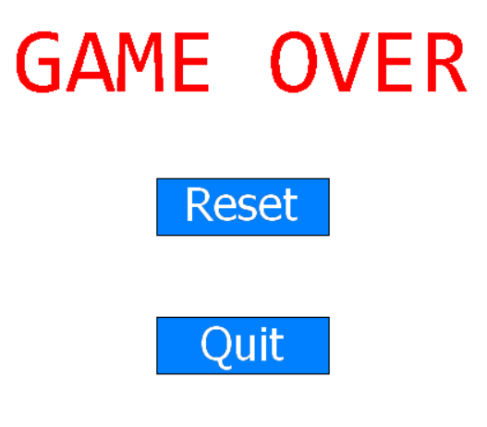

**VI. Scoring**

Score is gained by getting a matching line on the slot machine.

**VII. Art / Multimedia Index**

|  |  |
| --- | --- |
| Background  <https://opengameart.org/content/sci-fi-background> |  |
| Buttons  (Based on class example assets) |  |
| Jingle_18  <https://opengameart.org/content/miscellaneous-jingle> |  |